* 3 types of Web languages
  + HTML: hypertext markup language
  + CSS: cascading style sheets
  + Javascript
* 3 sections
  + HTML section: first and last tag of every web page
  + Head section: provides info but is not displayed on the page
  + Body section: contains all info to be displayed
* HTML rules
  + 1. All code goes inside of brackets < >
  + 2. Most code has a start and end tag
  + 3. End tags have a forward slash with the brackets </ >
  + 4. All code must follow LIFO
    - LIFO: Last in - first out
  + 5. Save with the extension htm or html
  + 6. With tags use lowercase letters only
  + 7. Comment code “<!--comment-->”
  + 8. Attributes are added to start tags
    - Attribute: defines the characteristic of a start tag
    - Structure: <code keyword=”change”>

**Master file**

<!DOCTYPE html>

<html>

<head>

<!--Katelyn Blackburn-->

<title>ADD TITLE HERE</title>

</head>

<body>

PUT CONTENT HERE

</body>

</html>

**White Space**

<p> </p> - paragraphs (double space)line

<br /> - break (single space)

<hr /> - horizontal rule (horizontal line)

**Headings**

<h1> </h1> - biggest

<h2> </h2>

<h3> </h3> - default size

<h4> </h4>

<h5> </h5>

<h6> </h6> - smallest

**Center**

<center> </center>

**Physical Styles**

<b> </b> - bold

<strong> </strong> - bold

<i> </i> - italics

<em> </em> - italics

<var> </var> - italics

<u> </u> - underline

<s> </s> - strikethrough

<strike> </strike> - strikethrough

<sup> </sup> - superscript

<sub> </sub> - subscript

<big> </big> - increases font size

<small> </small> - decreases font size

bac

**Color**

Background: <body bgcolor=”color”>

Text Color: <body text=”color”>

<body bgcolor=”color” text=”color”>

Image as a background: <body background=”name.jpg”>

**Font Tag**

Font Color: <font color=”#00cc99”> </font>

-Want to code the colors - hexadecimals

Font type: <font face=”"Arial Black", Gadget, sans-serif”>

Font size: <font size=”#”> - use 1-6 - 1 is small, 3 is default, 6 is big

**Images**

<img src=”name.jpg” />

SRC: src=”name.jpg”

Width: width=”#”

Height: height=”#”

Border: border=”#” - number represents the line thickness

Alt: alt=”Chuck Norris”

Hspace hspace=”#” - number represents the horizontal space around the image

Vspace vspace=”#” - number represents the vertical space around the image

Align align=” “ - top, middle, bottom, texttop, absmiddle, absbottom, baseline

**Structure Elements**

<header> </header> - content placed at the top of a web page

<footer> </footer> - content placed at the bottom of a web page

<section> </section> - major topic areas on a website

<article> </article> - subsections covering a single topic

<aside> </aside> - content containing a side issue to the topic

<nav> </nav> - surrounds hyperlinks

<figure> </figure> - surrounds images

<figcaption> </figcaption> - surrounds the image’s caption

<hgroup> </hgroup> - surrounds a header section

<thead> </thead> - surrounds the header section of a table

<tbody> </tbody> - surrounds the body of a table

<colgroup> </colgroup> - used to name columns

**Lists**

**Ordered List (Numbered List) :**

<ol> </ol> - only use one time - placed at beginning and end of the list

<li> </li> - line - surrounds each item on the list

Example:

<ol>

<li> apples </li>

<li> bananas </li>

<li> grapes </li>

</ol>

**Unordered List (Bullet List) :**

<ul> </ul> - only use one time - placed at beginning and end of the list

<li> </li> - line - surrounds each item on the list

Example:

<ul>

<li> apples </li>

<li> bananas </li>

<li> grapes </li>

</ul>

**Hyperlinks**

<a href=”<https://www.apple.com/>“> Apple </a> - External hyperlink

<a href=”food.html”> Food Glorious Food </a> - Internal hyperlink

<a href=”<mailto:katelyn.l.blackburn@lvpioneers.org>?subject=Question”>Contact Us</a> -Email

<a href=”<http://google.com>”> <img src=”google” /> </a> - Picture link

Creating Hyperlinks that anchor to a specific location

1. Name the location - use the id=”name” attribute
2. Create the link
   1. Linking inside the same webpage - <a href=”#name”> Link </a>
   2. Specific link to a different webpage - <a href=”page.htm#name”> Link </a>

Image Map/Hotspot

1. Create the map
2. Divide the image - shape, coords, href, alt
   1. Shape - rect, circle, poly
   2. Coords- x1,y1,x2,y2 - x,y,r - x1,y1,x2,y2,x3,y3, etc.
3. Apply the map - usemap=”#name” in the image tag

<img src=”image.jpg” alt=”” usemap=”#name” />

<map name=”name”>

<area shape=”rect” coords=”235,120,310,150” href=”tips.htm” alt=”Tips” />

</map>

**Tables**

<table> </table> - surrounds the table - use once

<tr> </tr> - table row - surrounds the row

<td> </td> - table data - surrounds content

<th> </th> - table header - bold and center content - replaces <td>

**Table Attributes**

Border <table border=”10”>

Merging Columns <th colspan=”#”> - type the number of columns to merge

Merging Rows <td rowspan=”#”> - type the number of rows to merge

Bgcolor <table bgcolor=”color”> - the whole table

<tr bgcolor=”color”> - one row

<td bgcolor=”color”> - one cell

Resizing the table <table width=95%”>

**Changing tab icon**

<link rel=”shortcut icon” type=”image/x-icon” href=”name.jpg” /> - has to be in <head>

**The naming attribute**

class=”name”

id=”name”

**Attaching the modernizr**

<script src=”modernizr-1.5.js”> </script>

**Attaching the stylesheet**

<link href=”name.css” rel=”stylesheet” type=”text/css” />

**Target Attribute**

Target options - _blank (opens a new tab), _self (does not open a new tab), new (names the tab)

<base target=”new”> - change all links

<a href=”home.htm” target=”new”> Home </a> - open only one hyperlink in a new tab

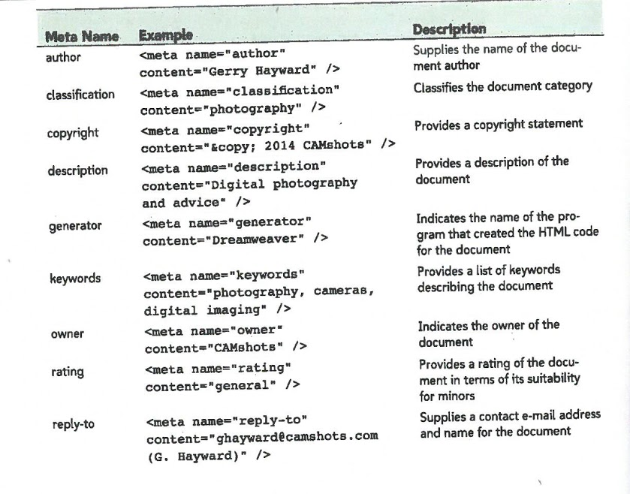

**CSS Notes**

**Character Encoding**

@charset “encoding”; Ex: @charset”utf-8”;

**Defining Web Fonts**

@font-family {

Font-family: name;

Src: url(‘name’) format(‘type’);

}

**CSS comment**

/* comment */

**CSS Structure**

HTML_tag {

Property : value;

}

**Pseudo-Code**

:hover

:link

:active

:visited

:focus

:first-of-type

:nth-of-type(6)

:first-of-type:first-line

:first-letter

:after

Direct Child - immediate tag that follows the parent

parent>child

section>p

Changing multiple tags

H1, h2, h3, h4, h5, h6{}

**Color**

Color : white;

Color : rgb(255, 255, 255);

Color : rgba(255, 255, 255, 0.5);

Color : hsl(38, 90%, 60%);

Hue - tint of color

Saturation - intensity of the color - percentage

Lightness - brightness - percentage

Background-color : white;

**Font/Text**

Font-family : font;

Font-size : size;

Absolute: cm, mm, inches, pt (points), pc (pica)

Relative: em, ex, px, %

Letter-spacing : size; (kerning)

Word-spacing : size;

Font-weight : type; bold, bolder, lighter, 100-900, normal

Font-style : type; italic, oblique, normal

Font-variant : type; small-caps

Text-align : type; left, right, center, justify

Text-indent : size;

Text-decoration : type; underline, overline, blink, line-through, none

Text-transform : type; uppercase, lowercase, capitalize

**HTML**:

Group elements:

<address> </address> surrounds contact information, makes it italic

<blockquote> </blockquote> indent your text.

<cite></cite>

**CSS**:

List-style-type: none, circle, square, upper-roman, lower-alpha, ;

List-style-image: url(name.(file_type));

List-style-position: type; outside or inside (flips where bullets are at)

**Background**

Background-color : rgb(255,255,255); hsl(39,100%,95%);

Background-image : url(name.png);

Background-repeat : type;

Type: no-repeat, repeat, repeat-x, repeat-y, round, space

Background-position : vertical horizontal;

Vertical: top, middle, bottom

Horizontal: left, center, right

**Float**

-Allows elements to be placed on the same row

Float : type;

Type: left, right, both

**Clear**

-Clears the float so elements don’t group together

Clear : type;

Type: left, right, both

**Margin**

-Space between the border and the next page element (Outside of border)

Margin : top right bottom left; 5px 5px; (top/bottom together and right/left together)

Margin-top: size;

Margin-left: size;

Margin-right: size;

Margin-bottom: size;

**Padding**

-Space between the content and the border (inside the border)

Padding : top right bottom left; 5px 5px; (top/bottom together and right/left together)

Padding-top: size;

Padding-left: size;

Padding-right: size;

Padding-bottom: size;

**Display**

Display : type;

Types: block, inline, flex, initial, inherit, none

**Border**

Border : type thickness color;

Types : solid, double, dotted, dashed, inset, outset, groove, ridge, none

**Position**

Position : type;

Top: size; (vertical position)

Left: size; (horizontal position)

Types: absolute, static, relative, fixed, inherit

**Rounded Corners**

Border-radius: size;

**Overflow (Scroll bars)**

-Limits the space for an element

Overflow : type;

Types: visible, hidden, scroll, auto\

-Must include a sizing element

Height : 450px;

White-space: nowrap;

**Filters**

Filter : type();

Types -

contrast(%)

grayscale(%)

invert(%)

opacity(%)

saturate(%)

sepia(%)

brightness(dec)

blur(px)

dropshadow(px px px color)

hue-rotate(#deg)

**Expanding the height on an area with a float**

Html::after {

Clear: both;

Content: “”;

Display: table;}

**Setting up a Grid**

HTML:

<div class=”row”> </div>

<div class=”col-”> </div> - must be inside row tags (<div class=”row”> </div>)

CSS:

1. Clear all row floats:

Div.row{

clear : row; }

2. Expand the container:

Html::after {

Clear: both;

Content: "";

Display: table; }

3. Float the columns:

div[class^="col-"] {

Float: left;}

4. Set column column widths:

div.col-1-1 {width : 100%;}

div.col-1-2 {width : 50%;}

div.col-1-3 {width : 33.33%;}

div.col-2-3 {width : 66.67%;}

div.col-1-4 {width : 25%;}

div.col-3-4 {width : 75%;}

**Border-box**

-webkit-box-sizing: border-box;

-moz-box-sizing: border-box;

box-sizing: border-box;

**Flexboxes**

1. Define the flexbox

display: -webkit-flex;

display: flex;

2. Set the direction and wrap

-webkit-flex-flow: direction wrap;

flex-flow: direction wrap;

Direction Options: row, column, row-reverse, column-reverse

Wrap Options: nowrap, wrap, wrap-reverse

3. Define the size of the boxes

-webkit-flex: grow shrink basis;

flex: grow shrink basis;

Grow: rate of growth from the base

Shrink: overall resizing

Basis: initial size

**Scalability**

Scalability for the HTML document:

<media name=”viewport” content=”width=device-width, initial-scale=1” />

Scalability for the CSS document:

Mobile

@media only screen and (max-width: 480px) {}

Tablet

@media only screen and (min-width: 481px) {}

Desktop

@media only screen and (min-width: 769px) {}

**Navicon**

1. Hyperlink the navicon image in the HTML document

<a id=”navicon” href=”#”> <img src=”navicon.png” alt=”” /> </a>

1. Hide the img in CSS

a#navicon {

Display: none; }

1. Activate it in mobile view

@media only screen and (max-width: 480px) {

a#navicon {

Display: block;

}

Nav.horizontal ul {

Display: none

}

a#navicon:hover+ul, nav.horizontal ul:hover {

Display: block;

}

}

**Print Stylesheets**

**Applying Stylesheets to different views :**

<link href=”tf_print.css” rel=”stylesheet” media=”print” />

Media Choices: all, screen, print

**@page pseudo-class :**

-Allows pages to have different styles

@page {

size : width height; ex.- size: 8.5in 11in;

}

**Adding the href attribute beside the hyperlink**

a::after {

Content : “ (“ attr(href) “) “;

Word-wrap : break-word;

}

**Placing articles on separate pages**

article:nth-of-type(n+2) {

page-break-before: always;

}

**Avoid Splitting Content**

img, ol, ul {

Page-break-inside: avoid;

}

**Widows and Orphans**

p {

Widows : 3;

Orphans : 3;

}